Ubuntu

My personal favorite was Ubuntu for desktop (#1 in this list) and Red Hat for servers (#5 in this list).

If you are new to any of the distros listed in the top 5, read the rest of the article to understand little bit more about those distros and find out whether your favorite Linux distribution made it in the top 5.

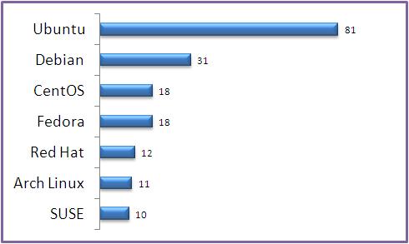

Fig: Favorite Linux Distribution Voting Results

1. Ubuntu



Like most of you, Ubuntu is my #1 choice for desktop Linux. I use it both at home and work. Ubuntu is the #1 in the Linux desktop market and some use Ubuntu for the servers also. Ubuntu offers the following three editions.

Ubuntu Desktop Edition

Ubuntu Server Edition

Ubuntu Notebook Remix

Additional Details:

Home Page: http://www.ubuntu.com

Ubuntu Download Page

Created by: Canonical Ltd., (who also provides commercial support, if you need it)

Used As: Desktop and Server

Latest Version: Ubuntu 9.04

Read more about Ubuntu Distribution at wikipedia.

2. Debian



Debian is also called as Debian GNU/Linux, as most of the basic OS tools comes from the GNU Project. Lot of other famous distributions are based on Debian, which includes our #1 distro Ubuntu and many others — such as Knoppix, Linspire, Damn Small Linux etc.,

Additional Details:

Home Page: http://www.debian.org/

Debian Download Page

Created By: Ian Murdock

Latest Version: Debian 5.0.1

3. Fedora



Fedora is sponsored by Red Hat. If you are interested in experimenting with the the leading technologies, you should use fedora, as the release cycle is very short and fedora tends to include the latest technology software/packages in it’s distribution.

Additional Details:

Home Page: http://www.fedoraproject.org/

Fedora Download Page

Created by: Fedora Project (sponsored by Red Hat)

Latest Version: Fedora 11

Based On: Red Hat Linux

4. CentOS



If your organization does not want to spend money on purchasing Red Hat support, but still want all the benefits of the red-hat distribution, this is obviously the best choice, as this is totally based on the red-hat enterprise Linux.

As you can imagine the Nort American Enterprise Linux vendor mentioned in the quote below is Red Hat.

From the CentOS website: CentOS 2, 3, and 4 are built from publically available open source SRPMS provided by a prominent North American Enterprise Linux vendor. CentOS is designed for people who need an enterprise class OS without the cost or support of the prominent North American Enterprise Linux vendor.

Additional Details:

Home Page: http://www.centos.org/

CentOS Download Page

Created by: CentOS Project

Latest Version: CentOS 5

Based on: Red Hat Linux

5. Red Hat



This is my favorite server distribution. If an organization doesn’t mind spending dollars on purchasing the red-hat support, this is always my #1 recommendation to any organization who runs mission critical applications.

On a side note, one of the reason I like Red Hat Linux for mission critical production application is that Red Hat tends to take some of the new features from Fedora, which is well tested by the community.

Additional Details:

Home Page: http://www.redhat.com/

Red Hat Download Page

Created by: Red Hat

Latest Version: Red Hat Enterprise Linux 5